Edge Computing: The Future of Real-Time Data Processing

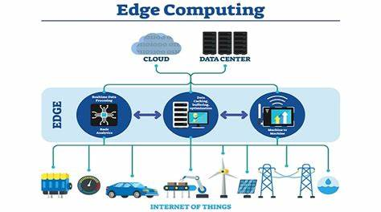
Image Source: https://www.sundaymail.co.zw/edge-computing-matters
In recent years, the rapid growth of technologies like, the Internet of Things (IoT), Artificial Intelligence (AI), Data Science(DS), has created massive demand for accelerated data processing. Cloud computing has been the keystone of data storage and analytics, but as more devices are being interconnected with the cloud computing, the limitations of cloud computing are becoming perceptible. Edge computing come into view as a complementary technology, which is offering real-time processing, reduced latency, and enhanced efficiency. As already we have the cloud computing which is so prominent then why there is a need for edge computing? So, in this article, we will traverse the reasons behind need for edge computing and how it provides benefits over cloud computing.
What is Edge Computing?
Edge computing is the process of bringing information storage and computing abilities closer to the devices that produce that information and the users who consume it. This "edge" can be a device, sensor, or edge server located near the data-producing source. Unlike cloud computing, which relies on centralized data centers to process information, edge computing reduces the distance data must travel, enabling faster processing and real-time decision-making. Traditionally, applications transmit data from smart devices like sensors and smartphones to a central data center for processing. However, the unprecedented complexity and scale of data have outpaced network capabilities. By shifting processing capabilities closer to users and devices, edge computing systems significantly improve application performance, reduce bandwidth requirements, and give faster real-time insights.

What is the difference between Edge Computing and Cloud Computing?
It’s crucial to understand that edge computing doesn’t replace cloud computing; rather, they complement each other. Cloud computing excels at large-scale storage, analysis, and long-term data management, while edge computing ensures real-time processing for critical applications. Together, they create a robust and efficient computing environment. Organizations can leverage the strengths of both to achieve optimal performance, cost-efficiency, and scalability.
While both edge computing and cloud computing are essential for modern technology, they differ fundamentally in how they process and manage data. Edge computing is running workloads at the edge—that is, closer to devices and end users. On the other hand, cloud computing is a broad term that includes running all types of workloads in a cloud service provider’s data center.

How Edge Computing Works?
In edge computing, data is processed locally on devices or nearby edge servers rather than being sent to a central cloud. For example, in an autonomous vehicle, sensors collect real-time data about the environment. Instead of sending all the data to the cloud for analysis, the vehicle processes this information locally in near real-time, enabling faster decision-making that is critical for safety.
Edge computing networks rely on a combination of local devices, edge servers, and gateways to perform computations. The system only sends relevant or summarized data to the cloud for further analysis or long-term storage, reducing the amount of data that needs to travel over long distances.
Edge computing operates by bringing computation and storage closer to both data producers and consumers. The deployment of edge computing varies across different use cases, generally falling into two main categories.
Upstream Applications: In upstream applications, the focus is on collecting data from smart sensors and devices, followed by transmitting it to data centers for further processing. Edge computing strategies in upstream applications involve distinguishing between these types of data sources, transmitting only critical information to the data center.
Downstream Applications: In downstream applications, the priority is on delivering data to end users. Examples include live video streaming, online gaming, or virtual reality video feeds. Edge computing in downstream use cases aims to reduce network latency, ensuring users experience real-time events.
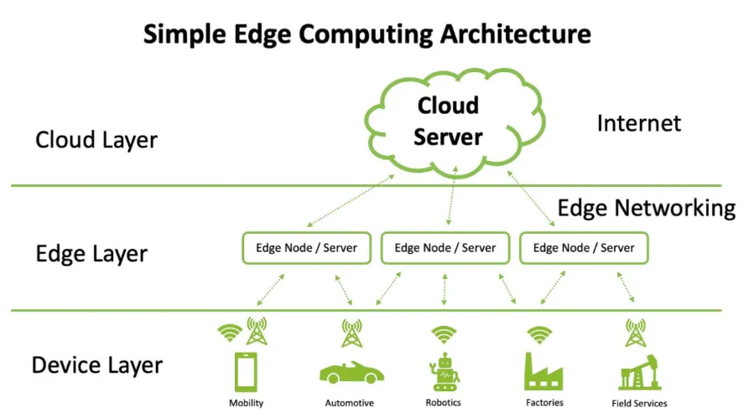Image Source: https://vajiramandravi.com/quest-upsc-notes/edge-computing/

Why is edge computing important?
Edge computing is becoming more popular because it allows enterprises to collect and analyze their raw data more efficiently. More than ever, organizations need instant access to their data to make informed decisions about their operational efficiency and business functions. When appropriately used, edge computing has the potential to help organizations improve safety and performance, automate processes, and improve user experience. Here are some benefits of edge computing.

Reduced latency and increased speed
In many industries, technology demands almost instant transfer of data. Take the example of a piece of robotic machinery on a factory floor. If a production incident makes it unsafe for that robot to keep operating, it needs to receive that information as fast as possible so it can shut down.

Improved data security
With edge computing, the majority of data is processed and stored locally. Any information that needs to be sent back to the data center can be encrypted before transmission. Enterprises also use edge computing to comply with data sovereignty laws, such as the General Data Protection Regulation (GDPR), by keeping any sensitive data close to the source.

Increased productivity
Enterprises improve operational and employee productivity by responding more quickly to information. By analyzing data collected at the source, organizations can improve areas of their facilities, infrastructure, or equipment that are underperforming. Edge computing can be teamed with artificial intelligence and machine learning tools to derive business intelligence and insights that helps employees and enterprises perform more productively.

Remote data collection
It is challenging to collect data from places with unreliable connectivity and bandwidth. Establishing compute and data storage capabilities at the network edge helps enterprises collect and transmit data from distant oil fields, industrial zones, and offshore vessels.

Reduced costs
Sending large quantities of data from its origin to centralized data centers is expensive because it requires more bandwidth. The edge computing model allows you to decrease the amount of data being sent from sites to data centers because end users only send critical data. Depending on how much data your business sends and processes, this could significantly save operating costs.

Reliable performance
Edge computing often takes place in remote areas where internet connectivity is scarce. By setting up an edge computing environment, enterprises ensure that their operations reliably process, analyze, and store data. This significantly reduces the chances of suffering from operational downtime caused by network or connectivity disruption.

Which industries use Edge Computing?

Healthcare
Edge devices monitor critical patient functions such as temperature and blood sugar levels. Edge computing allows the healthcare sector to store this patient data locally and improve privacy protection. Medical facilities also reduce the data volume they send to central locations and cut the risk of data loss.

Manufacturing
The proliferation of Internet of Things (IoT) devices such as sensors and gateways has made edge computing systems prevalent in the manufacturing industry. Manufacturers utilize edge computing solutions to enable automation, collect data on-site, improve production efficiency, and allow rapid machine-to-machine communication.

Autonomous vehicles
Autonomous vehicles like self-driving cars are fitted with several IoT sensors that collect large amounts of data every second. They require real-time data processing for instant response and cannot rely on a remote server for split-second decision-making.
Additionally, autonomous vehicles interact more efficiently if they communicate with each other first, as opposed to sending data on weather conditions, traffic, accidents, or detours to a remote server. Edge computing is critical technology for ensuring their safety and ability to accurately judge road conditions.

Real Life Application of Edge Technology:
Autonomous Vehicles – GE Digital partner, Intel, estimates that autonomous cars, with hundreds of on-vehicle sensors, will generate 40 TB of data for every eight hours of driving. Therefore, wheels—edge computing plays a dominant role. Sending all the data to cloud is unsafe and impractical. The car immediately response to the events which has valuable data when coupled into digital twin and performance of other cars of its class.

Benefits of Edge Computing
1. Reduced Latency: One of the primary benefits of edge computing is its ability to reduce latency, or the time it takes for data to travel from the source to the processing point. By processing data closer to where it is generated, edge computing enables near-instantaneous responses, which is crucial for real-time applications such as autonomous vehicles, industrial automation, and online gaming.
2. Bandwidth Efficiency: Transmitting large amounts of data to centralized data centers can lead to network congestion and increased operational costs. With edge computing, only essential data is sent to the cloud, which minimizes bandwidth usage and reduces strain on the network.
3. Improved Security and Privacy: Edge computing can offer enhanced security and privacy because sensitive data can be processed locally without needing to be transmitted over the internet to distant servers. This can help mitigate risks related to data breaches, especially in industries like healthcare, where privacy is paramount.
4. Reliability: Edge computing ensures that even if the network connection to the cloud is interrupted, local devices can continue to function autonomously. This makes it an ideal solution for mission-critical applications, such as healthcare devices or industrial machinery.

Challenges and Future of Edge Computing
The expansion of edge computing in the industry is contingent on 5G, enabling faster real-time data analysis on devices. However, due to the limited rollout of 5G, optimal edge computing functionality cannot be achieved. The distributed nature of edge devices increases the attack surface and potential vulnerabilities, leading to data breaches and critical information leakage. Managing and storing large volumes of data generated at the edge poses a significant challenge due to the limited storage capacity and computational power of edge devices. Scaling edge computing deployments to accommodate growing workloads and user demands is challenging due to the limited processing power, memory, and energy resources of edge devices.: Deploying and managing edge computing infrastructure and devices present complexities, including remote device management, software updates, edge application deployment, and monitoring.
Despite these challenges, the future of edge computing looks promising. As technologies continue to evolve, particularly with the rise of 5G networks, the capabilities of edge computing will expand. 5G's high-speed, low-latency network infrastructure is expected to further accelerate the adoption of edge computing, especially in applications requiring massive amounts of real-time data processing.
Conclusion
As we move towards an increasingly connected world, edge computing is becoming indispensable for applications that require real-time processing, reduced latency, and better security. While cloud computing will continue to play a significant role in global data infrastructure, edge computing is paving the way for a more efficient, reliable, and responsive computing environment. Whether it's autonomous vehicles, smart cities, IoT devices, or healthcare technologies, edge computing is reshaping the future of technology by addressing the growing demand for faster, smarter, and more efficient data processing.

References
aws.amazon.com
https://vajiramandravi.com
https://aws.amazon.com/what-is/edge-computing/
https://www.geeksforgeeks.org/edge-computing/?ref=ml_lbp
https://vajiramandravi.com/quest-upsc-notes/edge-computing/

